1. The pie chart is showing the proportion of product categories contributing to sales. Now the financial department has what it needs: a chart showing the relative contributions to the sales for each category. Using your newly created table, they can assess which category are most successful and investigate further to decide if some products should be discontinued.

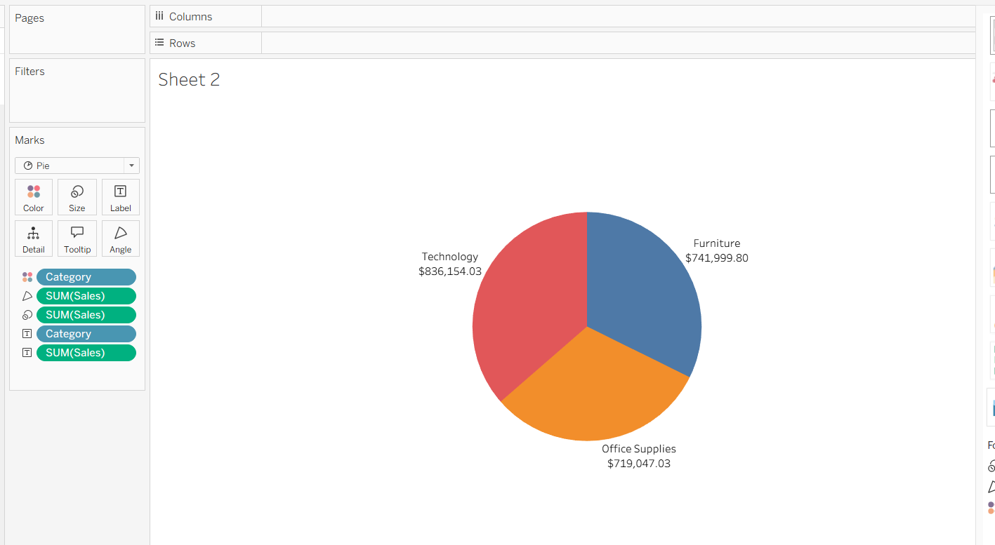

1. Now financial department can see the proportion year wise

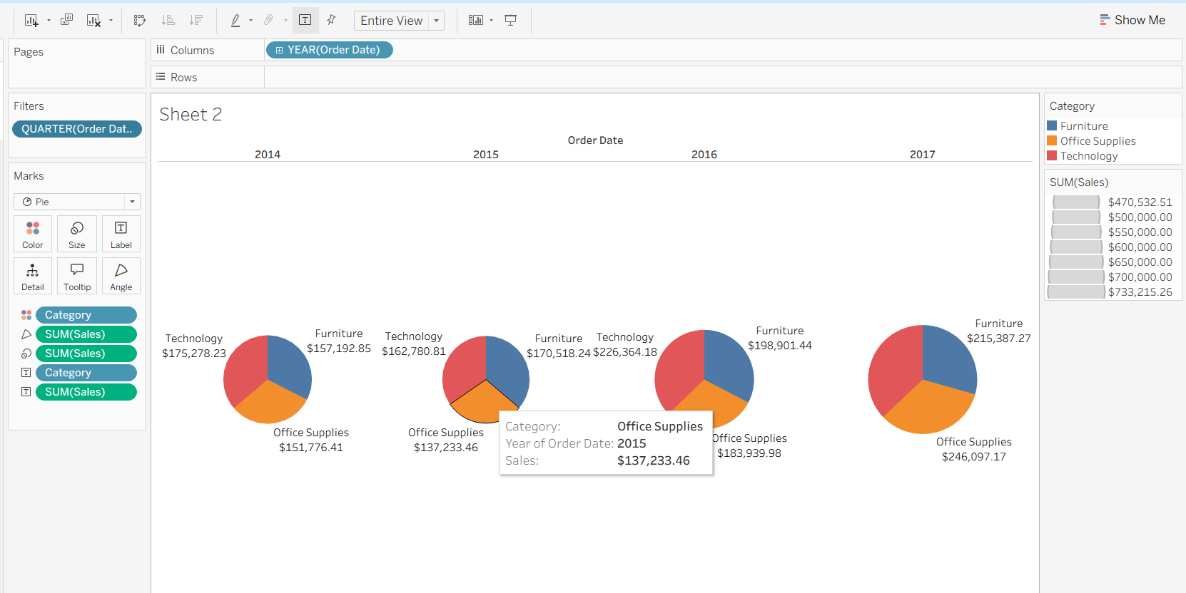

1. And the Quarter wise as well

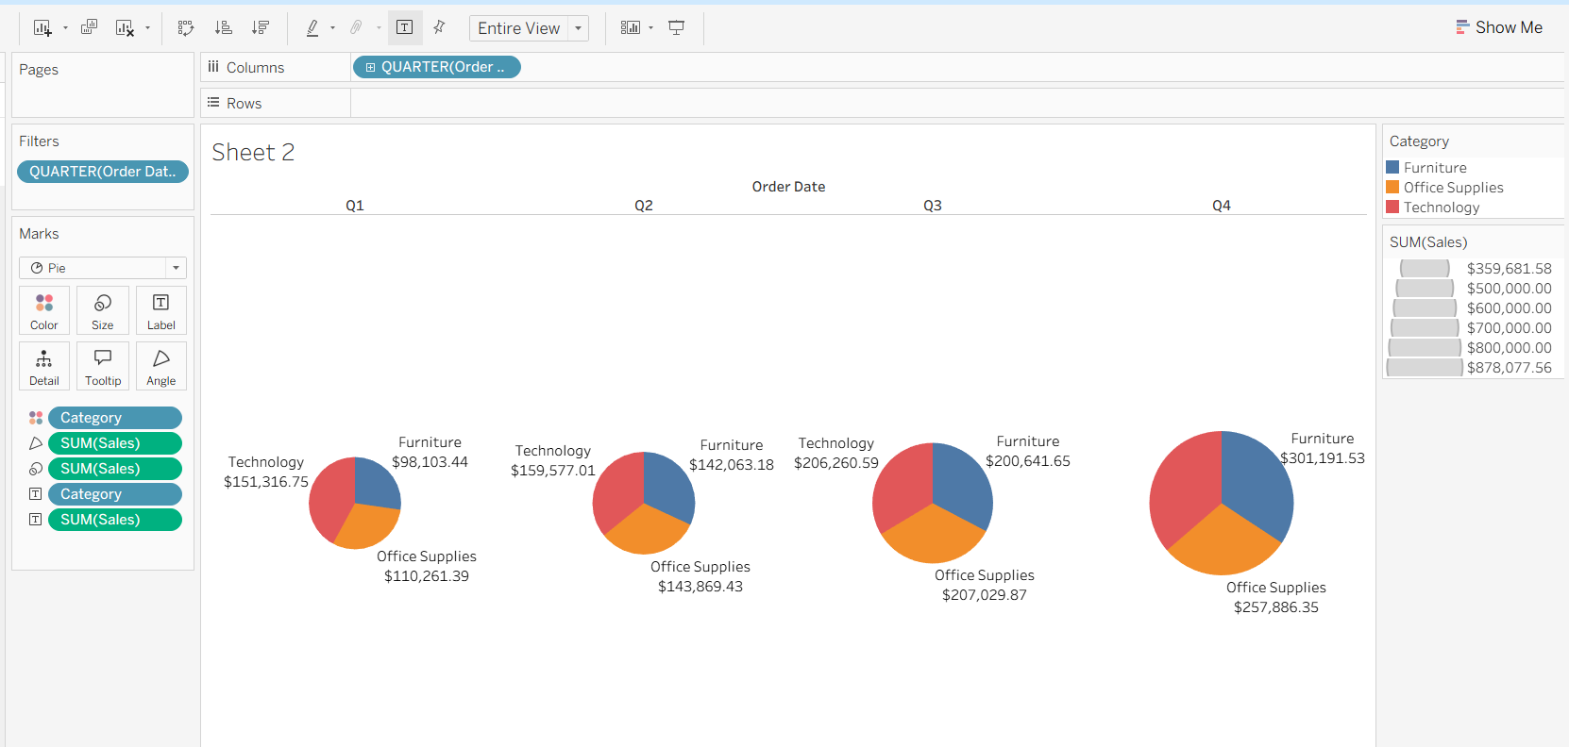

1. Below pie chart is showing the pattern for Segment and sales.

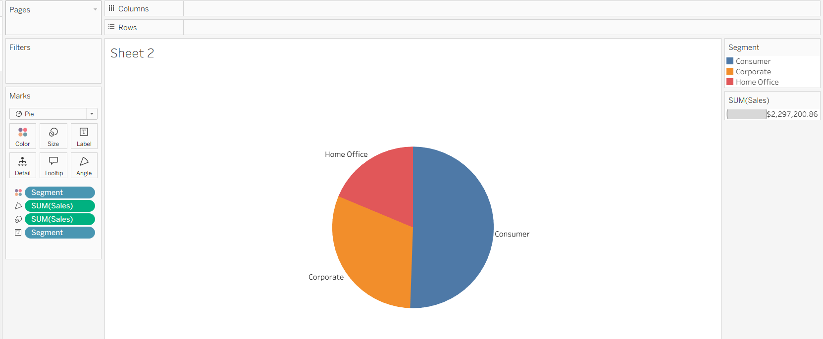

1. Below pie chart is showing Sub category wise Sales total

